SOCIAL STATISTICS
SOC 24100
Homework #9
Due: May 7

Questions
- What types of variables (nominal, ordinal, or interval-ratio) can we use to create a scatterplot?

- Which variable goes along the X axis of a graph (independent or dependent)? Which goes along the Y axis?

- What is a least-squares line?

- Given the regression equation Y=20,000 + 250X, do the following:
  - Identify and interpret a

  - Identify and interpret b

- If the r² value of the relationship between age and income was 0.41, how would you interpret that?

- How would we interpret an r of -0.23?

- The graph below shows the relationship between fertility rate and life expectancy—every circle represents one country, with the size of the circles representing the population size of the country and the colors representing region of the world.
  - Describe the relationship between fertility rate and life expectancy.

  - Choose one region of the world and make observations about their fertility rate and life expectancy in comparison to the other regions.

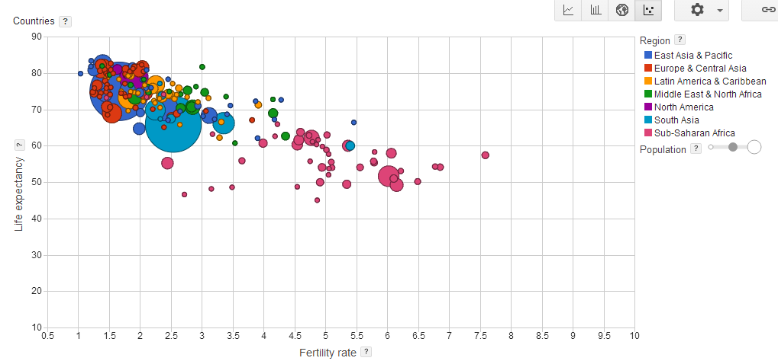

Source: https://www.google.com/publicdata/directory

